STEPS TO PLAY
1. Create a D&D 5E character using the rules in the Adventurers League Player's Guide or pick a pregenerated character if this is a level 1-4 adventure (I will have tokens set up for them). Track your character using a character sheet of any format you like (paper, online, text file, word, form-fillable pdf, etc.) and the Adventurers League adventure log sheets (which you will not need until after your first game).

Player's Guide available here: wizards.com/articles/events/adventurers-league-resources
Character Sheets, and Log Sheets available here: http://d20play.com/houserules.html
Pregenerated Characters available here: http://media.wizards.com/downloads/dnd/StarterSet_Characters.pdf

2. Download and install Chrome or Firefox browser (roll20 does not work well in internet explorer). If you run into any other technical issues, check here for possible solutions: https://wiki.roll20.net/Solving_Technical_Issues

3. Download and install Skype here: http://www.skype.com (use skype's handy test features to make sure everything is working on your end) (please set up push to talk settings if possible, they are at end of the "Optional Steps to Play" section below)

4. Go to roll20.net here and sign up: http://roll20.net

5. Gather your character, pencil, paper, start Skype, and, using Chrome or Firefox as your browser, open the campaign URL provided by your DM

You are ready to play! I will use your character sheet to set up your token and macros. When you join for the first time, I will show you how to use the macros, how to roll dice, and how to use the chat window.

OPTIONAL STEPS TO PLAY
Continue with this section after completing the STEPS TO PLAY section if you would like to learn more about Roll20 and about how your character's macros are set up. These steps are optional and the macro creation parts will be completed for you (if you get your character sheet to me 48 hours before the game).
Once you have the campaign url provided by your DM, you can go into the campaign at any time and work on your character.

1. watch the basic roll20 tutorial and read as much of the wiki pages as you want (refer back to these as required while completing the following steps)
basic roll20 tutorial
https://wiki.roll20.net/Getting_Started_Players
roll20 wiki:
https://wiki.roll20.net
custom power cards:
https://app.roll20.net/forum/post/1793309/script-powercards-2-thread-2

2. When I am done setting up a character, it usually takes up just a row or two of macro buttons at the top of the screen. Here are examples of what the bars look like for several characters. The last one shows they can get long for high level casters. When that happens, shortening the spell names will gain much of that space back.

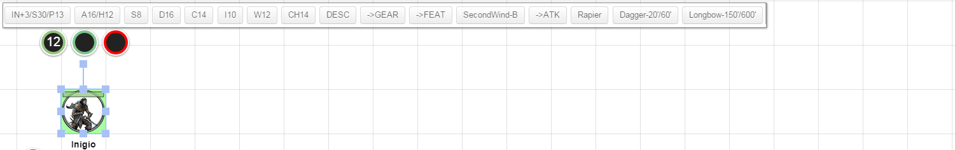

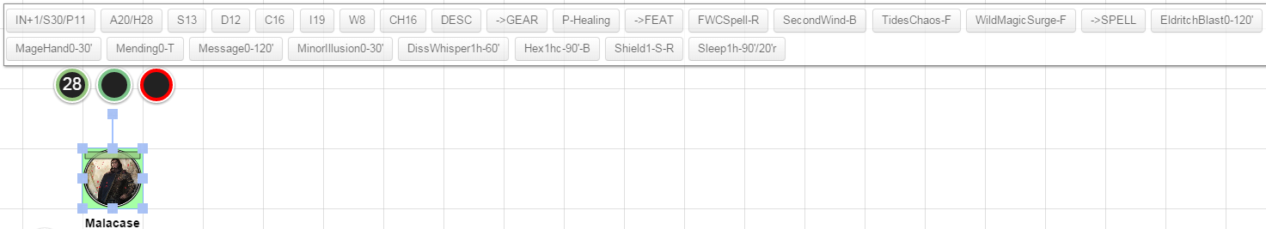

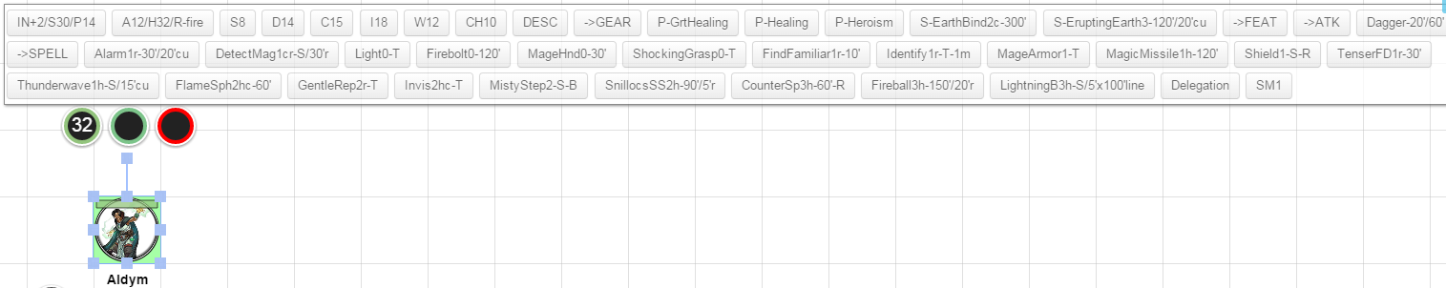

These macros are very compact. For example, one button press can roll an Ability Check, Skill Check, or Save, with or without advantage or disadvantage, and any associated notes can be added for reference too. Here is an example dex check (or SAVE or acrobatics check or etc.).

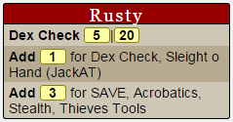

But my DM does not use the Power Cards API. Many DM's you play with will not have the Power Cards API. You can ask them to add it, but if they don't, that is ok, you can set up your macros to be used with or without the API. The format is the same either way except for you will need to add a "-" in front of each macro if the API is not in use. They will not be as pretty, but they will have all the info in them. This is also a handy trick to be able to keep editing your character and testing him even if the Power Cards API hangs and you are waiting for the DM to reset it. This works for the basic level of API functionality I use. The advanced features will not work this way, but I don't use those.

Example. The top output to the chat window on the right uses the Power Cards API (no "-" in the macro). The bottom output is without Power Cards API (with a "-" in the macro). The actual text of the macro is shown for reference.

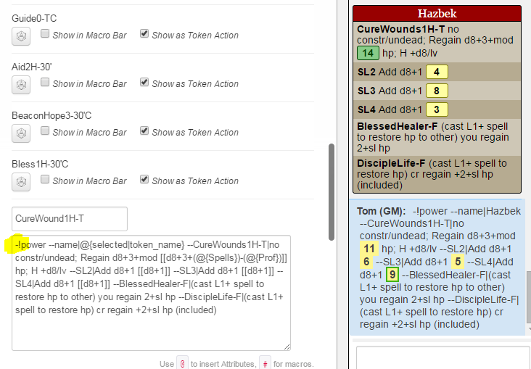
.
4. The following instructions describe how to make a character and macros from scratch.

5. Open the campaign URL provided by your DM. Click on the journal tab (near the top right of the window), double click on the character named "?? (Your Name)" (if there is not one, please email tgchristy@att.net to get one added before proceeding or ask to have a pregen copied for you if you want to start with one of those and make changes).

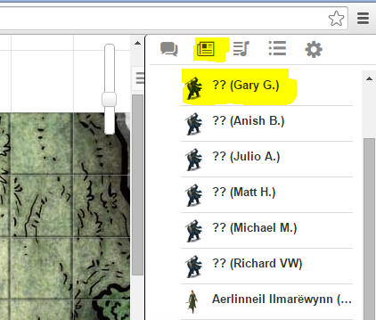

6. Click the "Edit" button in the window that opens.

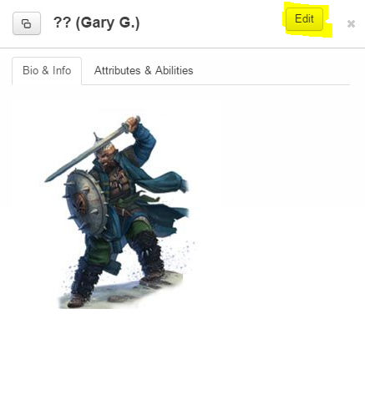

7. Edit the content.

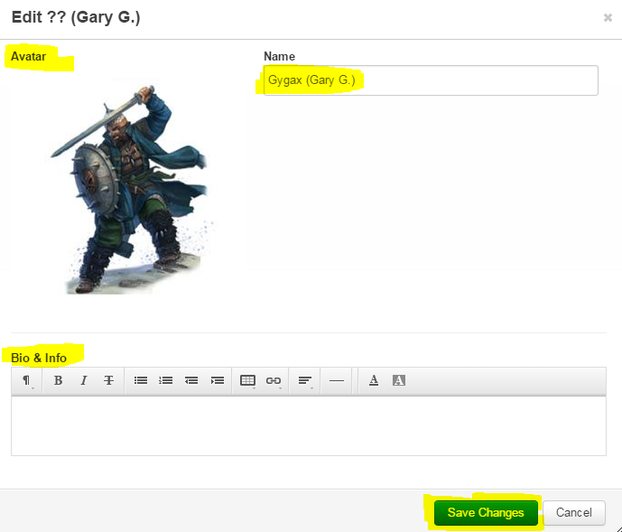

a. Change the name to your PC's name (with your name in parentheses)

b. Change the avatar to a picture that you want to use (by clicking on the "Remove" text that appears when you hover over the picture in the edit screen, then dragging in a new picture).

c. Add Bio & Info information as you like.

d. Save changes.

8. Edit the content in the "Attributes & Abilities" tab.

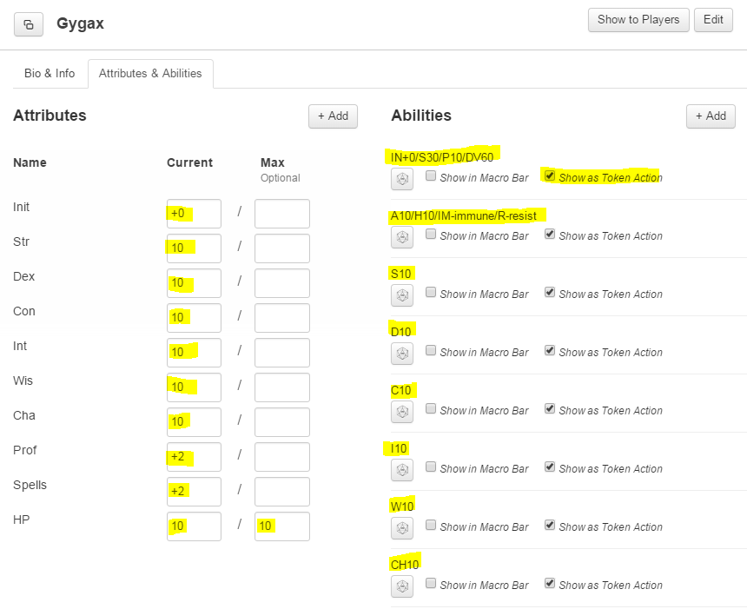

a. Update "Attributes." Click in the box and edit. These include initiative bonus, ability scores, proficiency bonus, spell bonus (note: spell bonus is the total of appropriate ability plus proficiency bonus) and HP (both current and max). Occasionally, you will need to add other attributes for use in your macros such as:

- Ki (for Ki save mod)
- KiPoints (for ki points per rest)
- Rages (for rages per day)
- LayHands (for paladin lay on hands hp per day)
- Etc.

b. Update "Abilities." Hover over the area to the right of the ability and then click on the pencil icon. These are macros that perform automatic checks or attacks for you. See following steps. Check "Show as Token Macro" for each so that it shows up on the screen as a button in the macro bar at the top of the screen when you click your token. It will look like this:

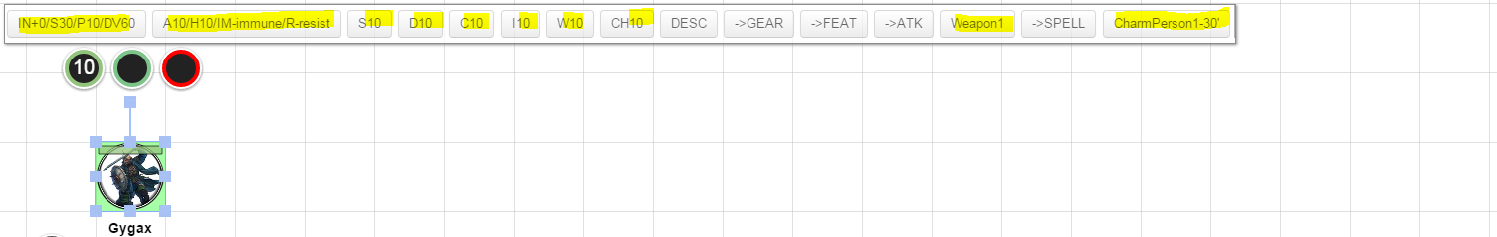

Some of these Macros are simply there as quick reference for the DM so he can see info such as your AC or passive perception by clicking on your token. Please update each of the titles with the correct information for your character.
The first macro includes speed and awareness info including Initiative, Speed, Passive Perception, and Special Sight (use DV for Darkvision, BS for blindsight, TS for truesight, leave off for no special vision).
The second macro includes defensive info including AC, HP, Immunities, and Resistances (if you have no immunities or resistances, leave these off).

c. You do not need to change the first macro (IN+0...) except to change its name unless you have something special to note.

d. Ability/Skill/Save Macros. Each ability score has a macro that is used to perform automatic ability/skill/save checks. These have the names S10, D10, C10, I10, W10, CH10. Please update the names to show your actual ability score in the title. Please update the macros to show bonuses and special factors as follows.

The general format used is as follows. Note that this must all be on one line with a single space between each part to work correctly. You only need to change the text in purple.

!power --name|@{selected|token_name} --Str Check|[[d20+floor(@{Str}/2)-5]]|[[d20+floor(@{Str}/2)-5]] --Add|[[@{Prof}]] for SAVE, Skill 1, Skill 2.

"!power" this calls the power cards API. Do not change this text.

"--name|@{selected|token_name}" this identifies the character in the chat window. Do not change this text.

"--Str Check|[[d20+floor(@{Str}/2)-5]]|[[d20+floor(@{Str}/2)-5]]" this identifies the check and rolls 2x and modifies each roll with the ability modifier (which is automatically calculated from the ability score attribute entered previously). The dice are rolled 2x to cover advantage or disadvantage. If those don't exist, we use just the first roll. Do not change this text.

"--Add|[[@{Prof}]] for SAVE, Skill 1, Skill 2." this lists the saves and skills associated with the ability. Change this text by adding/removing any saves or skills as appropriate. If you remove them all, also remove "--Add|[[@{Prof}]]" If you need to add more lines, make sure you use a different text than "--Add"

Edit view:

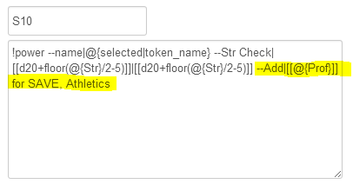

Chat view:

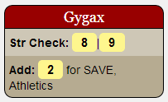

If you were rolling a save (which you have proficiency in) the result would be a 10 normally (the first modified d20 roll plus 2 for proficiency), a 11 with advantage, and a 10 with disadvantage.

e. Add attack, spell, etc. macros as you desire. A sample attack macro "Atk" is provided (I have many macros already made, so don't hesitate to ask for my assistance in filling these out).

Be sure to select "Show as Token Action" for each new macro.

The general format used is as follows. Note that this must all be on one line with a single space between each part to work correctly.

!power --name|@{selected|token_name} --XXXXX|YYYYY

"!power" this calls the power cards API. Do not change this text.

"--name|@{selected|token_name}" this identifies the character in the chat window. Do not change this text.

"--XXXXX|YYYYY" this starts a new line with bold text matching "XXXXX" followed by text matching "YYYYY." This can be repeated as long as "XXXXX" is different each time. There are certain specific text tags that are reserved by the API. In-line rolls can be used in the "YYYYY" part.

This is the bare bones of what the power cards API can do, for more info see: https://app.roll20.net/forum/post/1793309/script-powercards-2-thread-2

Attack Macro Example

Add a macro for each attack

Edit View:

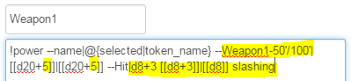

Edit the weapon name, the range (if it has range), the d20+0's to be d20+ your bonus to attack, the damage (the first d8), and the critical damage (the second d8).

Chat View:

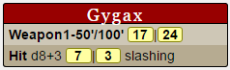

The first two numbers (17|24) are your attack roll. The first is the one you normally use. The second you use if you have advantage or disadvantage.

The two damage numbers (7|3) indicate normal damage on the left and additional critical damage (if applicable) on the right.

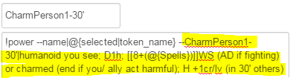

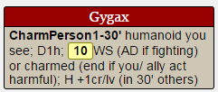

f. save changes

9. Create an avatar picture for your character. I will help you do that. I have some more advanced tools I use. If you are using these instructions for another game however, here are some steps you can do without my assistance.

a. Find a picture you want to use (google images is your friend).

b. Format the picture to a 560x560 pixel .jpg file (if you don't have the tools to do that, you can use the picture as-is if it is not too large)

c. Save the .jpg file to your computer.

10. Create a token picture for your character (if you are unable to complete the following, you can also use your avatar picture for your token)

a. download tokentool from here: http://www.rptools.net/index.php?page=downloads#TokenTool

b. Open tokentool by double-clicking on tokentool-1.0.b28.jar

c. In the token border selector, pick the sharp edged green circle (near middle of pull down menu)

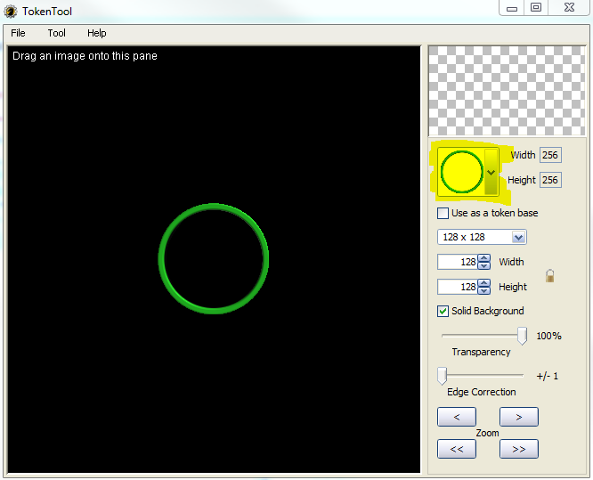

d. Drag the avatar picture you’re using from your folder to the token tool black area. Use the mouse to zoom in and out and pan.

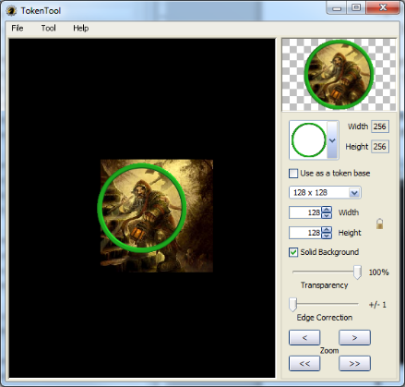

e. Select "File>Save Token" Save as a .png file with the same name as your avatar .jpg file.

11. Send an email to the GM letting him know your character is ready. Attach your avatar and token pictures and provide instructions to the GM on what each is for.

12. The GM will let you know once he has assigned the new picture to your token.

13. Set Skype to Push-to-Talk

a. Launch Skype, click the "Tools" menu and select "Options" to open the Skype Options window.
b. Click the "Advanced" button in the left pane to view the advanced settings.
c. Select "Hotkeys" in the left pane, under "Advanced."
d. Check "Enable keyboard shortcuts" check box to enable the shortcuts.
e. Click the check box in front of the "Toggle Mute (Push-to-talk)" entry to open the "Set Hotkey for Mute Microphone" window.
f. Select “Change selected shortcut button”, and assign any key, I recommend the ALT key (not as a combination press, but just holding the ALT key to talk). You will note, this actually sets the “Press to Mute”, but if you Mute your microphone (by pressing on your Mic button in the Skype Window when connected to a Call), then the “press to mute” becomes a “press to talk”.

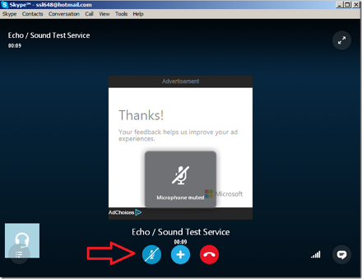

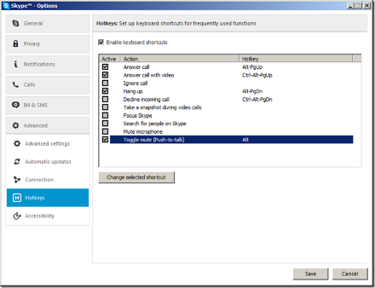

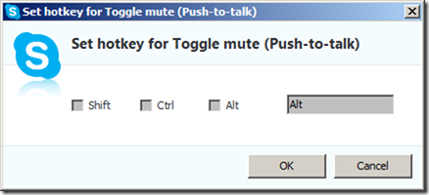

ROLL20 NOTES
API's Used

- Custom Power Cards

SPECIAL NOTE: The API's help to format Macros to look good in the chat window but they often stop working and require a reset of the scripts for the campaign. If you run into that, text or email me and I will reset them as soon as I can. In the mean time you can continue to edit and test the macros by adding a "-" in front of each.

Maptools Comparison

- Players can go into the campaign any time. So you don't need the server running to go in and edit your character.
- Players cannot add tokens or pictures to the map. Please email me a token and any pictures you will want to use before the game. I will work with you to assign the token to your character.
- Players cannot save tokens. I recommend saving any macros you make in a text file on your computer as backup. This may be fixed if you are a supporter with the character vault.

Fantasy Grounds Comparison

- Players can go into the campaign any time. So you don't need the server running to go in and edit your character.
- In combat, targeting is not automatic. Instead, announce your target and then click your macro button. Damage is added and subtracted from the tokens manually.

RULES AND OTHER RESOURCES ACCESS
D&D 5E Basic Rules
You can create your character using the Player's Handbook or the free basic rules available here as pdf:
http://media.wizards.com/downloads/dnd/DnDBasicRules(PrinterFriendly).pdf
or here as webpage:
http://dnd.wizards.com/products/tabletop/players-basic-rules

Pregenerated Characters
If you don't want (or have time) to create a character, you can use one of these pregenerated characters (I will have tokens already set up for them as well):
http://media.wizards.com/downloads/dnd/StarterSet_Characters.pdf

ABBREVIATIONS
I use the following abbreviations in many of my macros.

Spell Line
NameLevelxx-range/etc.-action

NameLevelxx abbreviations
The following abbreviations are used after the level for spells
c concentration required
h can be heightened
r can be cast as a ritual

range/etc. abbreviations
#/# short/long range in feet OR range/area for spells
S range self
T range touch

action abbreviations
<blank> standard action
B bonus action
F free action or feature
R reaction
Xxmin XX minute casting time

Action Types:
All powers use your action unless they state otherwise as shown below.
BONUS: takes your bonus action
REACTION: takes your reaction
REACTION (hit by rwatk): takes your reaction, triggered by being hit by ranged weapon attack

Saves and Ability Checks
SS: Strength Save
DS: Dexterity Save
CS: Constitution Save
IS: Intellegence Save
WS: Wisdom Save
ChS: Charisma Save
SC: Strength Check
etc.

Durations
D1h: Duration 1 hour
D1m: Duration 1 minute
EYNT: Until the end of your (the caster/attacker) next turn
ETNT: Until the end of the target's next turn

Other
AD: Advantage
atk: attack
chk: check
cr: creature
DA: Disadvantage
dmg: damage
lv: level
msatk: melee spell attack
mwatk: melee weapon attack
mwpn: melee weapon
rng: ranged
rsatk: ranged spell attack
rwatk: ranged weapon attack
rwpn: ranged weapon
sv: save
v: versus
wpn: weapon

